**EXPENSE TRACKER WEBSITE**

(By Kiran Kankariya)

**Abstract**

### In today's fast-paced world, managing personal finances efficiently is crucial for individuals to achieve financial where adjustments can be made to achieve financial wellness. stability and meet their long-term goals. To facilitate this process, the advent of expense tracking applications has revolutionized the way people monitor and control their expenses. This abstract highlights the significance of expense trackers, their key features, benefits, and the impact they have on personal financial management. Expense trackers are digital tools designed to record, categorize, and analyse one's expenses, providing a comprehensive overview of their financial activities. By systematically logging expenses, individuals can gain insights into their spending habits and identify areas

|  |  |  |  |  |
| --- | --- | --- | --- | --- |
| **Chapter No.** | **Title** | | | **Page No.** |
|  | **Abstract** | | | **I** |
|  | **Nomenclature** | | | **IV** |
| **1** | **INTRODUCTION** | | | **1** |
|  | **1.1** | Introduction | | **1** |
| **1.2** | Objectives | | **1** |
| **2** | **METHODOLOGY** | | | **4** |
|  | **2.1** | Introduction | | **4** |
| **2.2** | Implementation | | **4** |
| **2.3** | Finalization | | **4** |
| **3** | **CODING** | | | **5** |
|  | **3.1** | HTML | | **5** |
| **3.2** | CSS | | **7** |
| **3.3** | JAVASCRIPT | | **10** |
| **3.4** | MONGODB | | **12** |
| **3.5** | Advantages of HTML and CSS | | **14** |
|  | 3.5.1 | Price effective Multi-Platform Development | **14** |
|  | 3.5.2 | Offline Browsing | **14** |
|  | 3.5.3 | Consistency across multiple browsers | **14** |
|  | 3.5.4 | Simple to be told | **14** |
|  | 3.5.5 | Sensible page ranking | **15** |
|  | 3.5.6 | Quick responses | **15** |
|  | 3.5.7 | A far better user experience | **15** |
|  | 3.5.8 | Geolocation | **15** |
|  | 3.5.9 | Simple Maintenance | **15** |
|  | 3.5.10 | Short Code | **15** |
|  | 3.5.11 | Saves Time | **16** |
|  | 3.5.12 | International Internet Standards | **16** |
| **3.6** | Practical | | **16** |
| **5** | **FUTURE SCOPES** | | | **21** |
| **6** | **CONCLUSION** | | | **22** |
|  | **REFERENCES** | | | **23** |

**TABLE OF CONTENT**

**TABLE OF FIGURES**

|  |  |  |
| --- | --- | --- |
| **Figure No.** | **Title** | **Page No.** |
| **3.1** | **Flowchart of Methodology** | **4** |
| **3.1** | **HTML-Head Code** | **7** |
| **3.2** | **HTML-Body** | **7** |
| **3.3** | **CSS-Formatting** | **9** |
| **3.4** | **CSS-Color, Padding** | **10** |
| **3.5** | **Code-Table** | **16** |
| **3.6** | **Web Page-Home Page** | **17** |
| **3.7** | **Web page - Analysis** | **17** |
| **3.8** | **Code – Home Page** | **18** |
| **3.9** | **Code- Analysis** | **18** |
| **3.10** | **Code – Pie Chart analysis** | **19** |
| **3.11** | **Web Page - Interface** | **19** |
| **3.12** | **Web site – Login Page** | **20** |

**Nomenclature**

HTML – Hyper Text Markup Language

CSS – Cascading Style Sheets

JS – JavaScript

JSX – JavaScript Expression

JSON – Java Script Object Notation

**Chapter 1**

**INTRODUCTION**

* 1. **Introduction**

# In today's fast-paced world, managing personal finances has become increasingly important. Keeping track of expenses, budgeting effectively, and maintaining financial discipline can be challenging tasks for individuals and businesses alike. Fortunately, the advent of digital technologies has introduced innovative solutions to simplify the process. This report delves into the features and functionality of an expense tracker website, an online platform designed to help users monitor and analyze their financial activities conveniently.

# The expense tracker website serves as a virtual tool that empowers individuals and businesses to gain a comprehensive understanding of their spending habits and financial health. With its user-friendly interface and powerful features, users can effortlessly record and categorize expenses, set budget goals, track income streams, and generate insightful reports to guide their financial decision-making.

# The report explores the key functionalities of the expense tracker website, providing a detailed analysis of its features and benefits. It examines the various ways in which users can leverage the platform to gain control over their finances, identify potential areas of improvement, and optimize their financial well-being. Additionally, the report highlights the website's compatibility with different devices, ensuring seamless access across desktop computers, tablets, and smartphones for users on the go.

1.2 **Objectives**

1. Simplify Financial Tracking

2. Enable Budget Planning and Control

3. Promote Financial discipline in today’s world

**Chapter 2**

**METHODOLOGY**

**2.1 Introduction**

This chapter explains the methodology that was employed in gathering data and analysis which are relevant to the research. The methodology includes data collection, analysis of the info, choosing the optimum method, sorting of data and its management.

**2.2 Implementation**

We used HTML, CSS, and JavaScript for the implementation of our project. These languages are used for web development and web designing. We divided our team into 2 sub-teams namely Technical & Non-Technical Team. The technical team was assigned the task of coding and working on the Backend. The non-technical team was assigned the task of designing of website and connecting the website with the people.

**2.3 Finalization**

Figure 3.1: Flowchart of Methodology

**Chapter 3**

**IMPLEMENTATION**

This chapter is about the languages that we have used for the development of the website and why. We have used the languages hypertext markup language, CSS, and JavaScript to style our website into what it is right now.

**3.1 HTML**

It is a terminology that uses straightforward tags to markup and format the content that's created. These tags are based on angular brackets. Most of the tags have their closing tags excluding a couple of exceptions. The tag informs the browser that a hypertext markup language document has been started. Similarly, it tells the top the of hypertext markup language document.

The concept of the World Wide Web is inseparably tied with the Hyper Text Markup Language (HTML) - the language for describing web pages. HTML uses markup tags for describing structural semantics of a web page by denoting its elements: sections, paragraphs, headings, tables, lists, interactive forms and others. Elements with their corresponding attributes can be nested one in another, forming a typical tree structure. HTML enables also the inclusion of external resources into web documents, such as images, videos and other objects, which also become parts of a web page.

HTML5 introduces a set of new elements, which allow semantic marking of the document structure. They represent more specific replacement for the general div and span elements.

HTML5 introduces some other new elements, among which the most interesting are:

• elements that support multimedia and graphic content: video, audio and canvas. These elements are described in more detail in the following chapters;

• embed is used for the embedded content, handled by the plug-ins;

• elements for the display of quantities (progress, meter, time etc.);

• ruby for specifying annotations which are used in East Asian typographies.

Web forms: Web forms enable interaction between a web client and a web server. The data in the forms entered by the user is sent to a server, which responds according to the received values (e.g. returns the result of a search). The choice of the widgets used in forms is, however, limited. One of the good web development practices is the validation of more complex data on the client side. The latter is preformed using JavaScript or any other client side scripting languages. To provide new form widgets and to avoid validation of data on both sides, several custom form widgets were developed that can be used through third-party JavaScript libraries.

Before HTML5, playing of audio and video contents in a browser has only been possible by the use of third-party plug-ins with the Adobe Flash being the leading technology. Besides introducing new elements for embedding audio and video contents in a web page, HTML5 also defines an interface for manipulation with such content without the need for plug-ins.

HTML5 supports also browser-native rendering using SVG (Scalable Vector Graphics). SVG is an XML-based language for describing 2D vector graphics. Unlike Canvas, SVG enables rendering in high resolution at any level of magnification due to its vector nature. Today, SVG is used mostly for displaying static contents (maps, plans etc.) with the aid of browser plug- New technologies for web development 277 ins. SVG is based on a special XML object model through which the individual graphic objects can be accessed and manipulated using JavaScript. SVG enables also interactivity by using event-handlers assigned to any SVG graphic object.

The new notable trend on the Web today is the introduction of semantics in web documents. The web content is shaped and designed primarily to be read and understood by people; therefore a computer cannot provide any extensive help by analyzing, searching and processing the data. The introduction of semantics will eventually lead to the third generation of Web, the socalled Semantic Web

Figure 3.1: HTML-Head Code

Figure 3.2: HTML-Body

**3.2 CSS:**

The markup languages are used primarily to define basic structure of web documents and pages while on the other hand the final presentation and rendering are usually defined with CSS – a style sheet language which defines presentation semantics. The technique of designing web pages with CSS is almost 14 years old with the CSS 2.1 being the leading standard for the last 12 years.

It is outlined as a way to put forward sheet language that has internet design management over however an online website communicates with different web browsers together with the information and shows their hypertext markup language documents. This language permits internet developers to own management over varied parts and functionalities, just like the layout, colours, fonts.

The massive specification of CSS3 standard is divided into several modules which are developed individually with different progress speeds and dynamics. Various modules enable browser vendors to implement them incrementally. Several CSS3 modules are already supported by the majority of modern browsers. The new standard is completely compatible with the addition of new properties and functionalities.

CSS continues to be a fundamental technology in web development and has evolved to meet the demands of modern web design. Here are some new age use cases and relevant information about CSS in the current generation:

Responsive Web Design: With the increasing popularity of mobile devices, responsive web design has become essential. CSS offers responsive design techniques that allow web pages to adapt their layout and appearance based on the screen size and orientation of the device. This ensures a consistent and optimized user experience across different platforms.

Flexbox and Grid Layout: CSS now provides powerful layout options with the introduction of Flexbox and Grid. Flexbox enables developers to create flexible and dynamic layouts, making it easier to align and distribute elements within containers. Grid allows for more complex and grid-based layouts, enabling precise control over the placement of elements on a webpage.

CSS Frameworks: To streamline web development and improve productivity, CSS frameworks like Bootstrap, Foundation, and Bulma have gained popularity. These frameworks provide pre-designed CSS styles and components that developers can utilize to quickly build responsive and visually appealing websites.

Animations and Transitions: CSS animations and transitions enable designers to add visually engaging effects to web elements. This includes smooth transitions, animated hover effects, and complex animations that bring websites to life, enhancing user engagement.

Customization and Theming: CSS allows for easy customization and theming of websites. Developers can create multiple stylesheets, allowing users to switch between different themes or personalize the appearance of a webpage according to their preferences.

CSS Pre-processors: Pre-processors like Sass and Less extend the functionality of CSS by introducing features such as variables, mixins, and nested styles. These pre-processors simplify and streamline the CSS development process, making it more efficient and maintainable.

CSS-in-JS: In recent years, the concept of CSS-in-JS has gained traction. It involves writing CSS code directly within JavaScript, allowing for greater component-based styling and encapsulation.

CSS has become a cornerstone technology for creating visually stunning and responsive websites. Its versatility, compatibility, and ongoing development make it an essential skill for web developers looking to stay up-to-date with modern design practices.

Figure 3.3: CSS-Formatting

Figure 3.4: CSS-Color, Padding

**3.3 JAVASCRIPT:**

JavaScript is a popular versatile programming language that has evolved significantly since its inception in 1995. it offers a wide range of features for web development server-side development and desktop application. It was initially a lightweight scripting language for creating interactive web pages. however, it has grown and has become a full-fledged programming language. JavaScript supports asynchronous which allows developers to write non-blocking code that can handle multiple tasks simultaneously.

JavaScript is a powerful programming language that is widely used in web development. It enables developers to add interactivity, dynamic content, and functionality to websites, making them more engaging and user-friendly.

Client-Side Web Development: JavaScript is primarily executed on the client-side, meaning it runs within the user's web browser. This allows for dynamic and interactive web experiences without the need for constant server communication. JavaScript is responsible for handling user events, manipulating the DOM (Document Object Model), and updating web content in real-time.

Single Page Applications (SPAs): With the rise of SPAs, JavaScript has become crucial in creating responsive and highly interactive web applications. Frameworks like React, Angular, and Vue.js leverage JavaScript to build complex SPAs, providing smooth navigation, real-time updates, and seamless user experiences.

AJAX and API Integration: JavaScript enables asynchronous communication with servers through AJAX (Asynchronous JavaScript and XML) requests. This allows web applications to fetch data from APIs (Application Programming Interfaces) and update content without reloading the entire page. This functionality is essential for creating dynamic and data-driven websites.

Front-End Frameworks and Libraries: JavaScript frameworks and libraries have become increasingly popular in recent years. They provide pre-built components, reusable code, and architectural patterns that simplify web development. Frameworks like React, Angular, and Vue.js offer efficient ways to build complex user interfaces, manage state, and optimize performance.

Server-Side Development: JavaScript has expanded beyond the browser and is now used for server-side development as well. Node.js, a runtime environment built on Chrome's V8 JavaScript engine, enables developers to build scalable and efficient server applications using JavaScript. This allows for full-stack JavaScript development, where the same language can be used both on the client and server sides.

Mobile App Development: JavaScript frameworks like React Native and Ionic have gained popularity for mobile app development. These frameworks enable developers to build cross-platform mobile applications using JavaScript, targeting both iOS and Android platforms. This approach significantly reduces development time and effort by sharing code between platforms.

Game Development: JavaScript has also made its way into the game development space. Libraries and frameworks like Phaser and Three.js provide the necessary tools to create 2D and 3D games directly in the browser. JavaScript's performance improvements and WebGL support have contributed to its adoption in this field.

Internet of Things (IoT): JavaScript is increasingly being used for IoT development. Platforms like Johnny-Five and Node-RED enable developers to write JavaScript code to interact with hardware devices, sensors, and IoT ecosystems. This allows for the integration of web technologies and IoT, opening up new possibilities for smart home automation, industrial applications, and more.

JavaScript continues to evolve, with regular updates to the language and the introduction of new features. It remains a vital skill for web developers, offering a versatile and powerful toolset for creating modern, interactive, and dynamic web applications.

**3.5 Advantages of Using HTML and CSS:**

**3.5.1. Price Effective Multi-Platform Development**

One batch of code will be used across platforms, devices and totally different markets which is a plus as a result it leads to lower development and maintenance prices over {the internet the online the net} website or web application's time period, sanctionative U.S.A. to use these resources elsewhere. The current best follow for cross-platform (e.g., IOS and Android) application development may be a ‘hybrid’ approach, whereby internet standards are followed at intervals by a native application that may be placed within the iOS or humanoid store.

**3.5.2. Offline Browsing**

In a similar manner that ‘apps’ will be used offline, while not an online affiliation, HTML5 supports native storage of internet application code and content, through the offline application cache. this can be an amazing advantage to businesses, like publishers, United Nations agency will give offline internet expertise for readers on the move. The offline cache additionally produces important performance enhancements as a lot of the location or system code and content is accessed quickly and domestically. huge files can even be held on and retrieved once necessary as they’re held on domestically within the sort of cache.

**3.5.3. Consistency across multiple browsers**

Not all browsers support all websites or internet applications, however, the implementation of HTML5 and CSS3 helps the designer to form a compatible website or system at intervals for all browsers.

**3.5.3. Simple to be told**

HTML5 may be a relatively simple language to be told and implemented. And with what it permits you to form, it's a quite powerful tool further. Once you perceive the tags, you'll be able to even begin making your own hypertext markup language pages.

**3.5.5. Sensible page ranking**

If the inspiration of an internet site isn't semantically correct (i.e. unreadable, non-standard primarily based code) then the page itself won't attain an honest rank at intervals in search engines. HTML5’s new parts will be relied on once sites are being re-indexed on search engines, as specific mark-up options of HTML5 are useful once program results pages (SERPs) are being calculated.

**3.5.6. Quick Responses**

A hypertext markup language is incredibly quickly responsive because it will store cache domestically and retrieve it. It ensures that the websites are lightweight.

**3.5.7. A Far Better User Expertise**

HTML5 offers a wider variety of style and presentation tools across media varieties, giving the developers larger scope to provide far better internet sites and web applications. this can be very important for a business purpose of reading, as user engagement and retention are essential to accrued website and system use and conversion. making an accessible and usable website or system means users are going to be a lot of doubtless to interact.

**3.5.8. Geolocation**

HTML5 supports geolocation. Once a user opts to share their location a HTML5 application will use the user's location. this may be of primary importance once developing location primarily based services or apps.

**3.5.9. Simple Maintenance**

To create a worldwide modification, merely modify the design, and everyone’s personal online pages are going to be updated mechanically.

**3.5.10. Short code**

Short code and attributes that facilitate shortening the lengthy code. this can be a plus as the readability of the code will increase. it's additionally comparatively simple to edit because it is apparent text. it's a loose syntax and therefore will be manipulated.

**3.5.11. Saves time**

You will be able to write CSS and utilize multiple hypertext markup language pages. You will be able to outline a method for every hypertext markup language component and apply the same to several websites as you would like.

**3.5.12. International Internet Standards**

Currently, hypertext and markup language attributes are being deprecated and it's being suggested to use CSS. Therefore, it is a sensible plan to start exploiting the hypertext markup language pages to create websites compatible with future browsers.

**3.6 Practical:**

We have taken reference from the many budget tracker website, apps and made the interface accordingly so as to make the job of budget tracking easier for the user. We have first coded in basic html and made use of html tags like <head>, <style>, <body>, <table> and various tag attributes like bgcolor, height, width, cell -padding to design our webpage. To make this website look more presentable we have made use of tables to make the information we are providing look clean and spaced-out. To give the webpage an aesthetic view we have then added all the CSS styling. This is the element which makes the webpage look more professional.

Figure 3.5: Code-Table

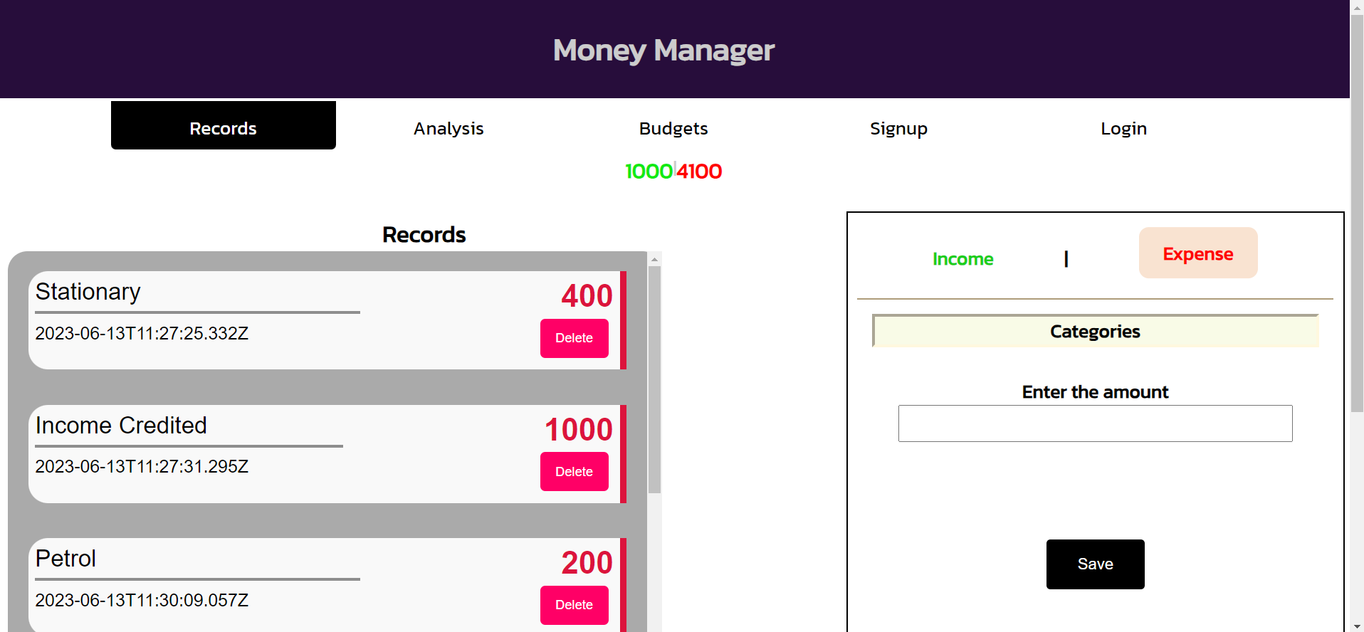

Figure 3.6: Web Page-Home Page

Figure 3.7: Web Page- Analysis Section

Figure 3.8: Code – Home Page

Figure 3.9: Code - Analysis

Figure 3.10: Code – Pie Chart analysis

Figure 3.11: Web page Interface

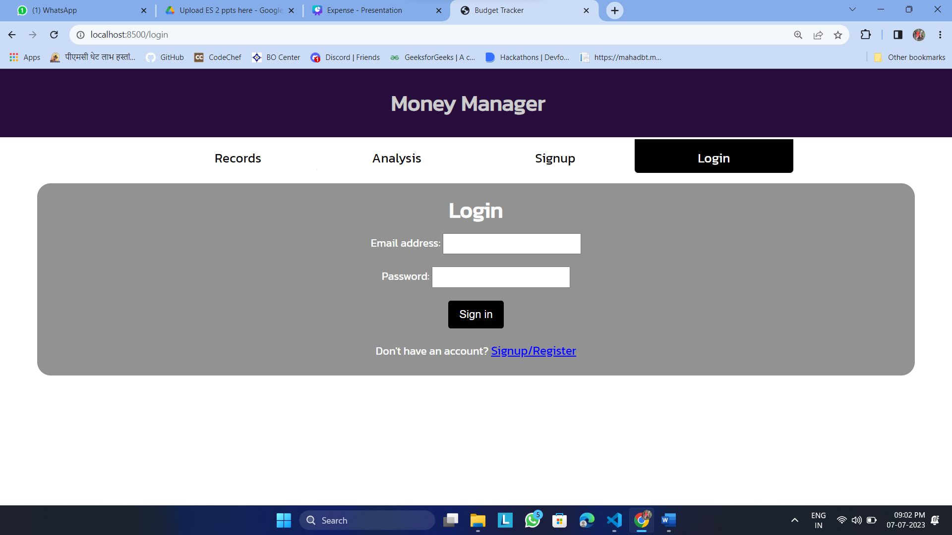

Figure 3.12: Website – Login Page

**Chapter 6**

**CONCLUSION**

# In conclusion, the budget tracker website represents a powerful tool for individuals and businesses seeking effective financial management. Throughout this report, we have explored the features and functionalities of the website, highlighting its ability to simplify financial tracking, enable budget planning, generate insightful reports, and promote financial discipline.

# By leveraging the user-friendly interface and robust features of the budget tracker website, users can gain a comprehensive understanding of their spending habits, set realistic budget goals, and track their progress towards achieving them. The platform's reporting and analysis capabilities provide valuable insights into spending patterns, allowing users to identify areas of overspending, make informed financial decisions, and optimize their financial health.

# Moreover, the website's compatibility across multiple devices ensures convenient access to financial information anytime and anywhere. Whether on a desktop computer, tablet, or smartphone, users can seamlessly manage their finances and stay on top of their budget goals, enhancing accessibility and convenience.